ADDRESS

809 Saratoga Drive

Durham, NC

27704

NAICS

|  |  |
| --- | --- |
| 541611 | 711120 |
| 611610 | 711320 |
| 611620 | 812199 |
| 621340 |  |

DIFFERENTIATORS

Because of her experiences, Marvis Henderson-Daye, the CEO, has a unique perspective as an employer, employee, disabled person, single-parent, and community activist. She overcame numerous obstacles and took control of her life. Dancing became one of her tools to living a rich and full life. Now, she uses dancing and storytelling to educate, motivate, empower, and entertain her audiences. As Chen (2018) described, dancing provides low-impact exercise and positive social engagement for the members. The community benefits because healthier people make better life decisions. To continue to provide quality services, the company use webinars to provide workshops, classes and social activities.

References

Chen, C. (2018). Designing the Danceable City. Journal of the American Planning Association,

Edwards, Scott. (n.d.). Dancing and the brain. Harvard Medical School Blavatnik Institute Neurobiology

PAST PERFORMANCE

* 2020 Virtual Line Dance Classes, Social Activities, Ubora Virtual Book Club
* 2018-2020 Creedmoor Elementary Schools of the Arts: Dance Instructor for Prekindergarten to 5th grade. Latisa McKnight, Principal, [mcknightlb@gcs.k12.nc.us](mailto:mcknightlb@gcs.k12.nc.us)
* 2017-2020 Durham Parks & Recreation: Line Dance Instructor. Jerome Johnson, Holton Resource & Career Center’s Assistant Director, [jerome.johnson@durhamnc.gov](mailto:jerome.johnson@durhamnc.gov)
* 2017-2020 Covenant Presbyterian Church: Line Dance Instructor. Sue McLaurin, Clerk of Session, [suemcpt@aol.com](mailto:suemcpt@aol.com).
* 2018-2019 Delta Women Health Awareness Day: Speaker. Contact Joan Packenham, Coordinator, [packenhm@niehs.nih.gov](mailto:packenhm@niehs.nih.gov" \t "_blank)

CORE COMPETENCIES

M. E. Henderson, Inc.’s philosophy is that dancing improves the participants’ quality of life because of the physical, mental, and social interactions. While dancing is a low-impact form of physical exercise, “A study in the New England Journal of Medicine by researchers at the Albert Einstein College of Medicine discovered ***that dance can decidedly improve brain health***” (Edwards, n.d.). To educate, promote, and demonstrate healthy living, exercise, and positivity, the company use the arts as nontraditional tools to educate and promote healthy activities. **Keywords: Instruction, healthy living, exercise, social engagement, entertainment, brain health, overcoming adversities**

BUSINESS SUMMARY

The core of M. E. Henderson, Inc.’s mission is to provide educational and social activities that promote healthy living by using dance as exercise and entertainment. The CEO and Chief Fun Officer’s goal is to inspire, motivate, educate, and empower people to overcome life’s adversities and celebrate every step that they make to become healthier and happier.

M. E. Henderson, Inc.

Capability Statement

EMAIL

contact@marvisfun.com

WEBSITE

Marvisfun.com

D&B

086187680

CERTIFICATIONS

HUB Certified

TELEPHONE

252-767-2780

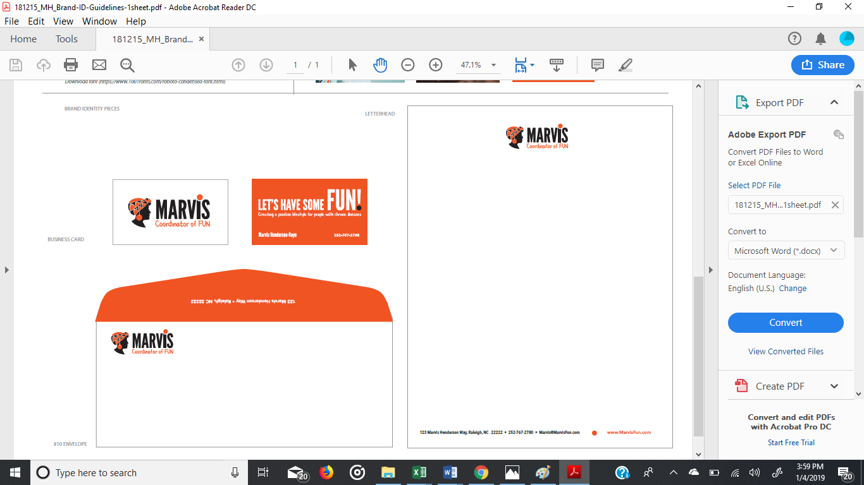

FAX

919-477-2650

CAGE CODE

8GJM3